Let's try to understand how does a Google image search engine work

There are two ways to do this.

1) Indexing the text surrounding any image and matching it with the given query. If query matches, the corresponding linked image is retrieved.

2) Going ahead, in addition to linking text surrounding an image to that image we can link all visually similar images to that image with the same text.E.g. consider an image/photo Img1 on any site with it's surrounding text Txt1. And lets say there are some other images Img2,Img3,Img4 etc. which may or may not have text but their (visual) content matches with the contents of Img1.

Now for given query, if Txt1 is a good match, the retrieved result can contain Img1 in addition to Img2, Img3, Img4, etc.

This is just one factor in addition to many other like matching query with text, features used to represent an image, page-rank of page containing an image, relevence, indexed database size available with search engine, etc.

Huge indexed database availability with Google is one of the reasons why Google can give you best results.

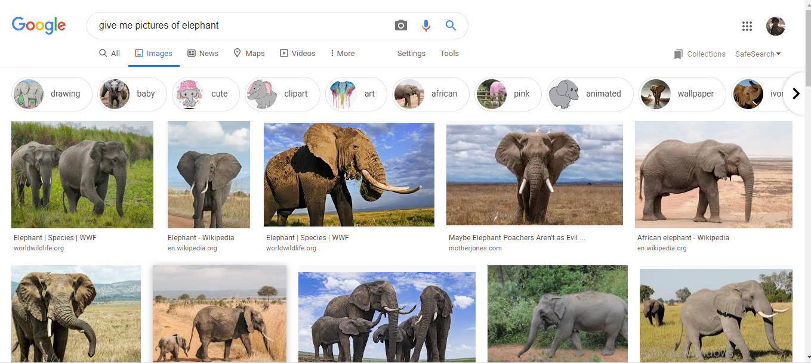

We would now try to understand Qanswer’s regular way to query images.

For this purpose, we would try to use the same text, “give me pictures of elephant”

